Or

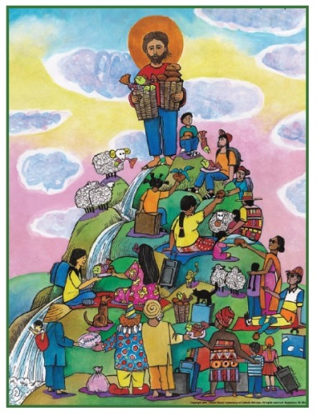

Global Migration Sunday — Order of Worship
Advent 1 | December 2, 2018
ENTRANCE
Greeting:
Pastor: From the rising of the sun to its setting,
Right side: From the East
Left side: to the West,
Front half: From the North
Back half: to the South,
All: Let the name of our God be praised!

Congregational Song:

Prayer for Illumination:
God, you call us to be in relationship, building community with one another, working with one another, supporting and healing one another. You call us into a community working for the common good of all people, making choices that bring hope, justice, truth and freedom to our world. You are the source of human dignity, and it is in your image that we are created. Pour out on us the Spirit of love and compassion. Enable us to reverence each person: to reach out to those in need, to value and appreciate those who differ from us, to share the resources of this nation, and to receive the gifts offered to us by people from other cultures. Grant that we may always promote the justice and acceptance that ensures lasting peace and racial harmony. Help us to remember that we are one family. Amen.

OR
Almighty God, we thank you for the gift of family, we thank you for the joy, love and friendship of family life. As our God, we ask you to provide protection and care for all families, especially those who face danger, hardships and threats as they move in search of safety and a better life.
Be with those who travel in danger and in your loving kindness lead them to a place of safety, peace and rest. Show comfort to those who are alone and who fear for their families who have been separated by violence, war, injustice and famine. As we focus today on global migration, we remember the difficult journey that Jesus’ family faced as refugees in Egypt. Help us to remember the suffering of all migrant and refugee families. We pray that all migrant and refugee families may be reunited with their loved ones and find the meaningful work they seek. Open our hearts and give us the courage to welcome every stranger as Christ in our midst. Amen.

WORD AND RESPONSE
First Lesson:
1 Kings 17: 8-16
and/or
Galatians 3: 19-29

The Immigrant Apostles’ Creed
The Immigrant Apostles’ Creed was written by Rev. Jose Luis Casal, the director of Presbyterian World Mission. He is an immigrant to the USA from Cuba.

I believe in Almighty God,
who guided the people in exile and in exodus,
the God of Joseph in Egypt and Daniel in Babylon,
the God of foreigners and immigrants.
I believe in Jesus Christ, a displaced Galilean,
who was born away from his people and his home, who fled
his country with his parents when his life was in danger.
When he returned to his own country
he suffered under the oppression of Pontius Pilate,
the servant of a foreign power.
Jesus was persecuted, beaten, tortured, and unjustly condemned to death.
But on the third day Jesus rose from the dead,
not as a scorned foreigner but to offer us citizenship in God’s kingdom.
I believe in the Holy Spirit,
the eternal immigrant from God’s kingdom among us,
who speaks all languages, lives in all countries,
and reunites all races.
I believe that the Church is the secure home
for foreigners and for all believers.
I believe that the communion of saints begins
when we embrace all God’s people in all their diversity.
I believe in forgiveness, which makes us all equal before God,
and in reconciliation, which heals our brokenness.
I believe that in the Resurrection
God will unite us as one people
in which all are distinct and all are alike at the same time.
I believe in life eternal, in which no one will be foreigner
but all will be citizens of the kingdom
where God reigns forever and ever. Amen.
Hymn:
Abraham Journeyed to a New Country (tune of Morning Has Broken #145)
Camina, Pueblo de Dios (#305)
Breathe on me breath of God (#420)

Second Lesson:
1 Thessalonians 3:9-13
Luke 21:25-36

Sermon:

Offertory Music:
God Will Take Care of You #130
O How I Love Jesus #170
Jesus Keep Me Near the Cross #301
Come O Thou Traveler Unknown #386
O God of Every Nation #435

Other Sending Songs:
We Are God’s People TFWS 2220
Caminando TFWS 2235
Go ye, go ye into the world TFWS 2239

